**DirectConnect**

It is a dedicated private connection without internet

Using WAN (Fiber optic network) connected Data Center to Direct Connect Location of AWS

**Direct connection location** is associated to region

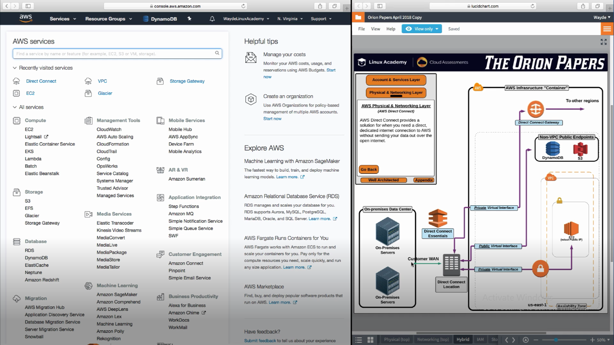

Direct Connect Gateway connecting to other regions. VPC’s should not have duplicate ip address for subnets/ec2 instances. If so it will be a duplicate and connection cannot be established

We cannot do this for china

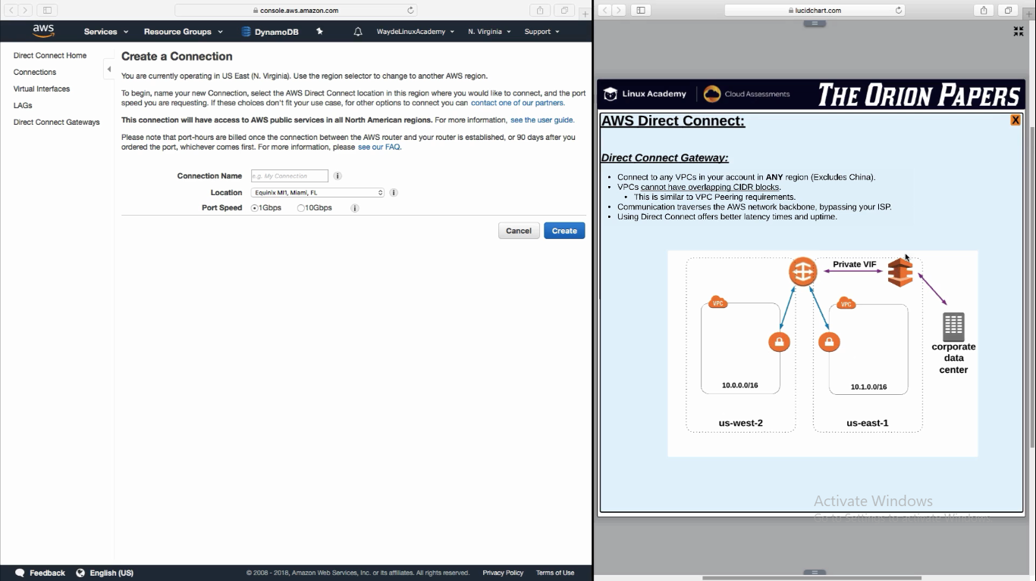

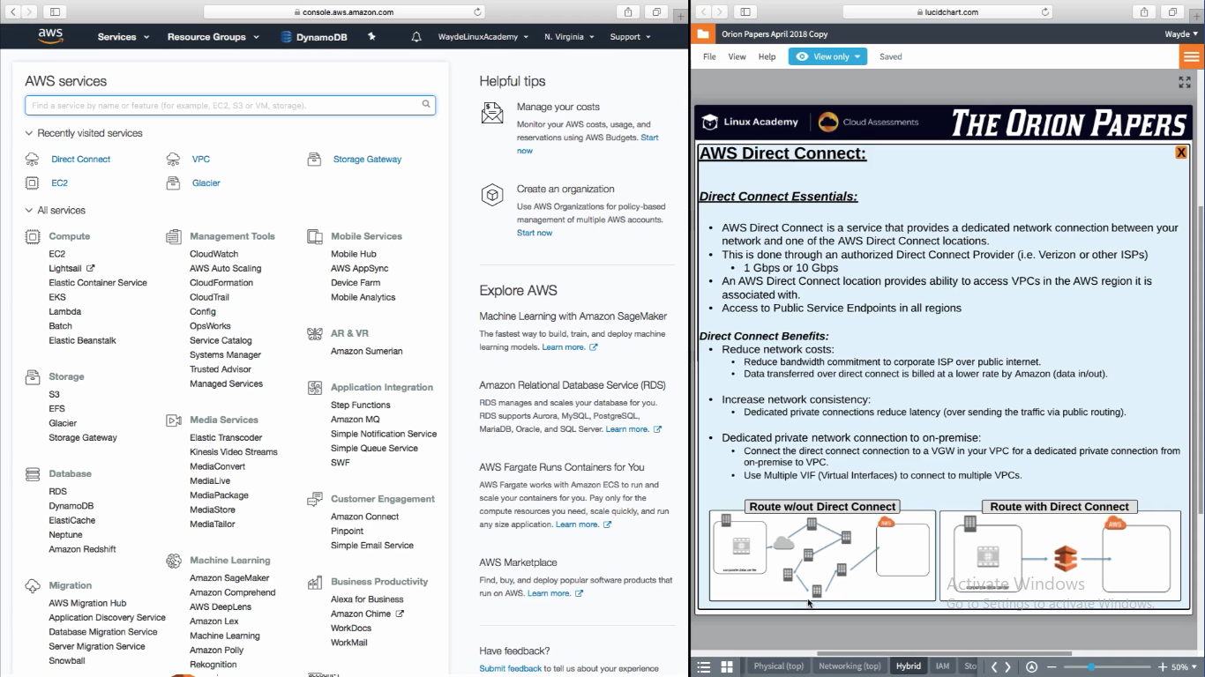

**VPC Peering**

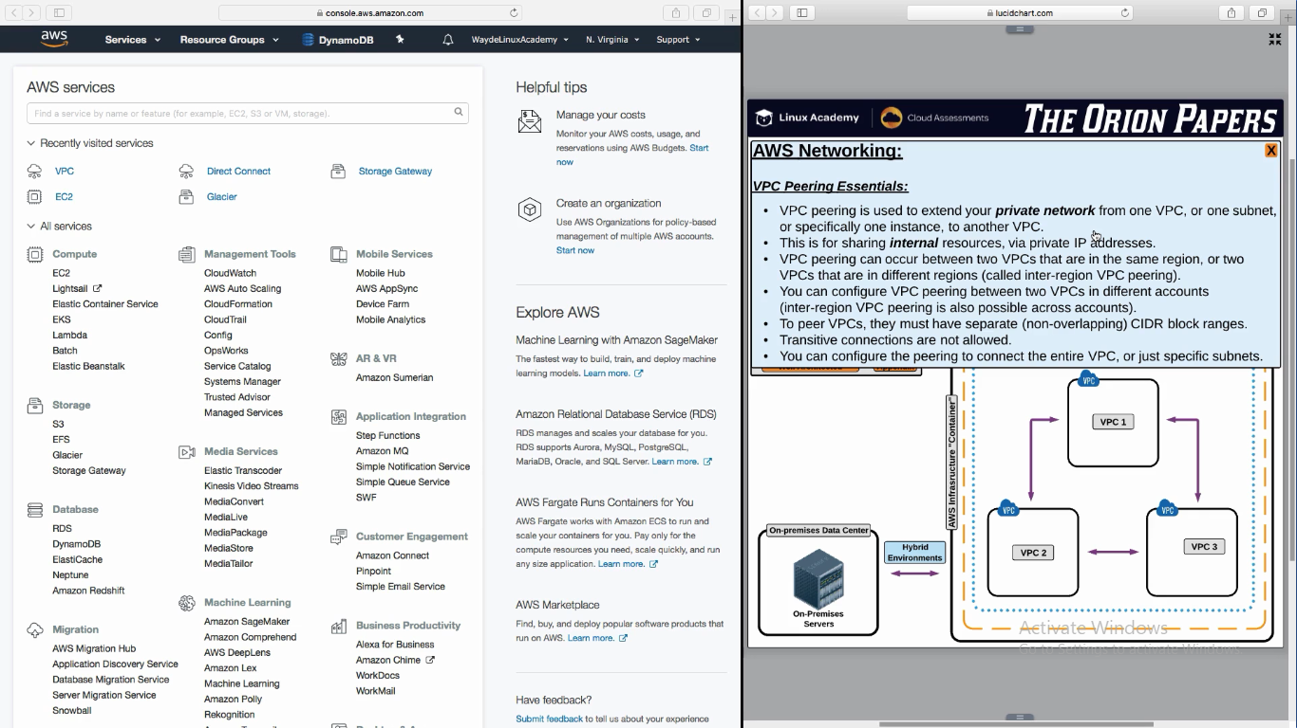

VPC to VPC peering is possible between regions

Peering is also possible between a subnet in a VPC to another subnet in another VPC

VPC peering between two VPC is possible even if it is owned by two different accounts, if the account owner approves it

We can make only particular subnet to contact each other in a VPC peering.

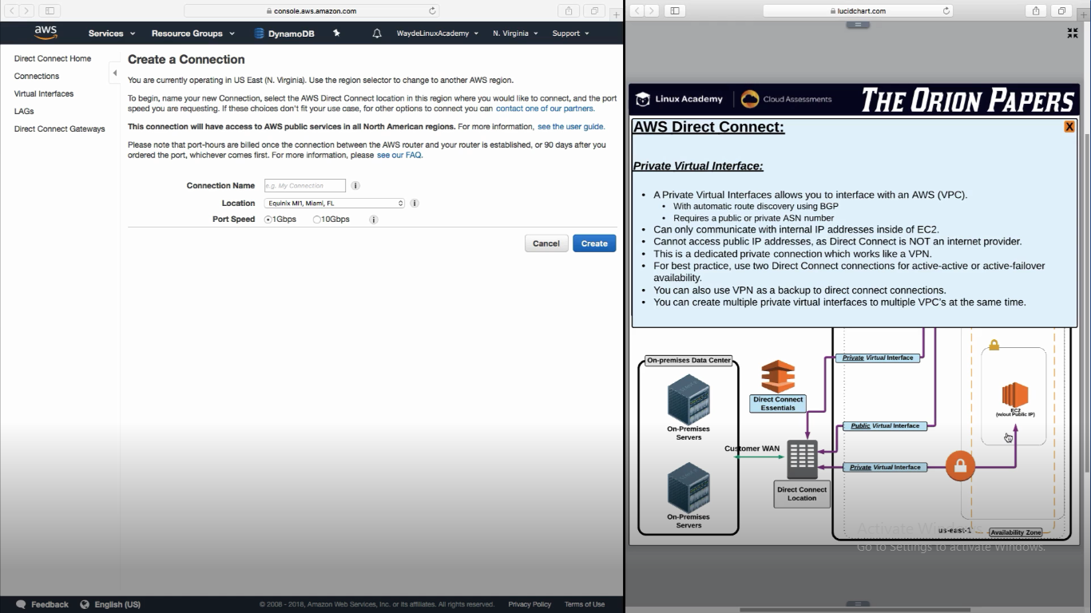

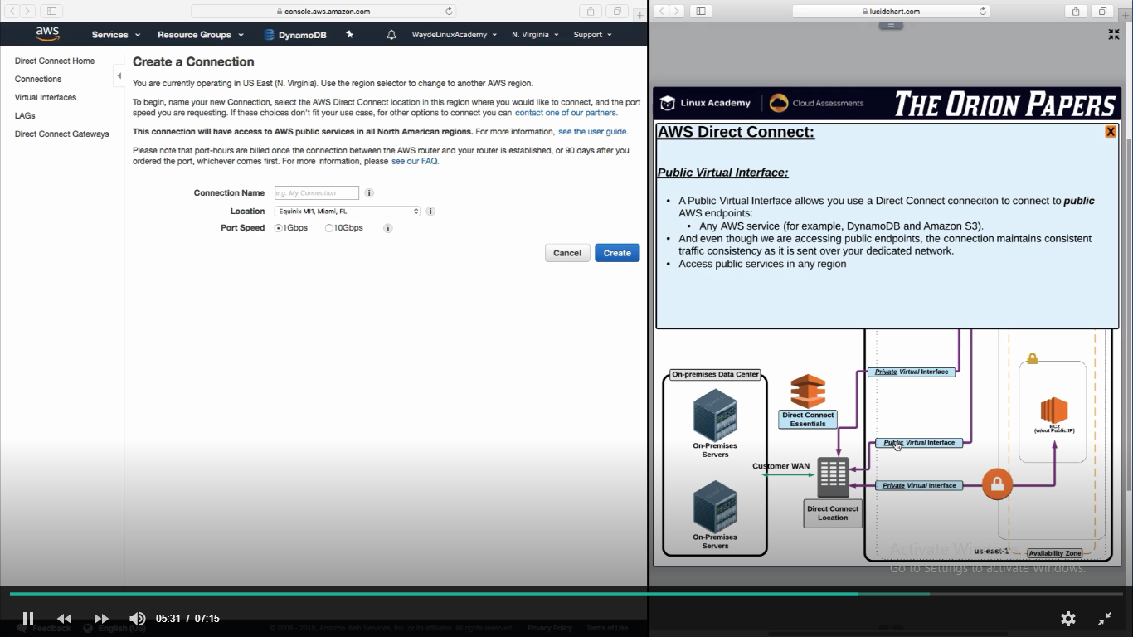

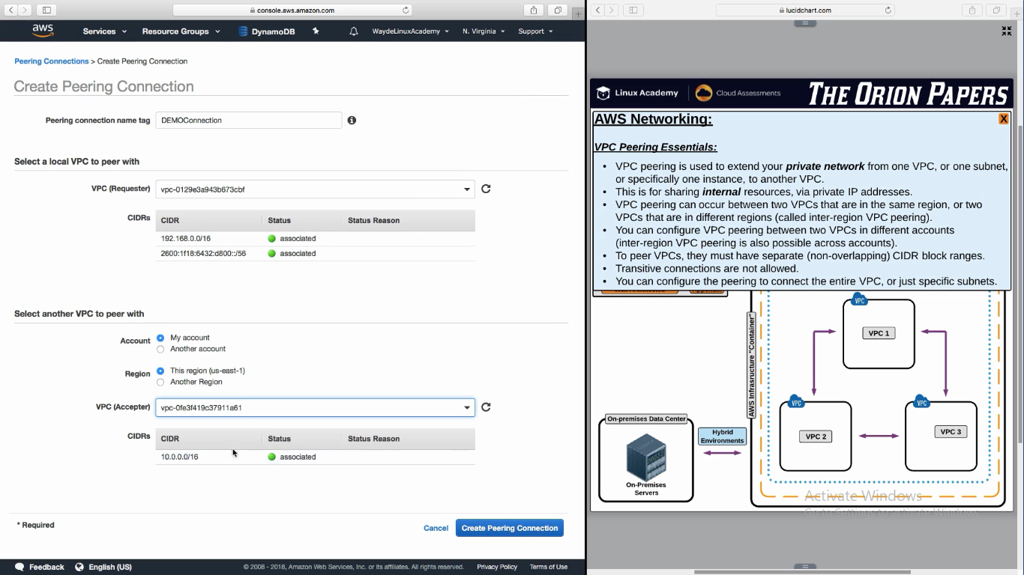

Modify route table in both VPC. Enter VPC2 ip in route table for VPC1 and vice versa.We are good.

**Handson**

Awsconsole -> Directy Connect Home -> Get started with direct connect

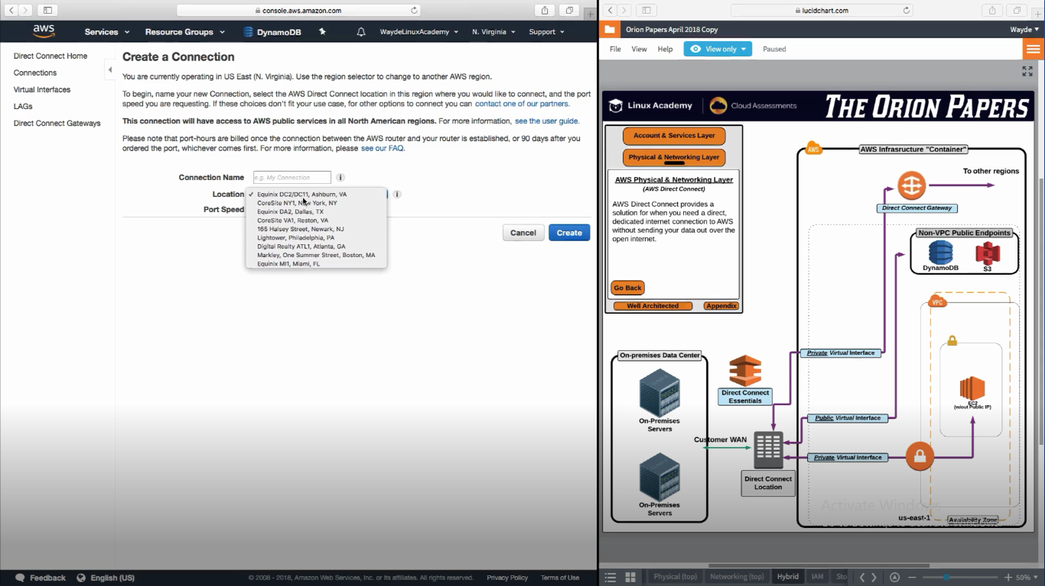

Once done, we have to give a letter of authorization to direct connection provider to authorize them to connect to aws backbone

**VPC Peering – Handson**

AWSConsole -> Network Content and Delivery -> VPC -> Peering Connection -> Create peering connection

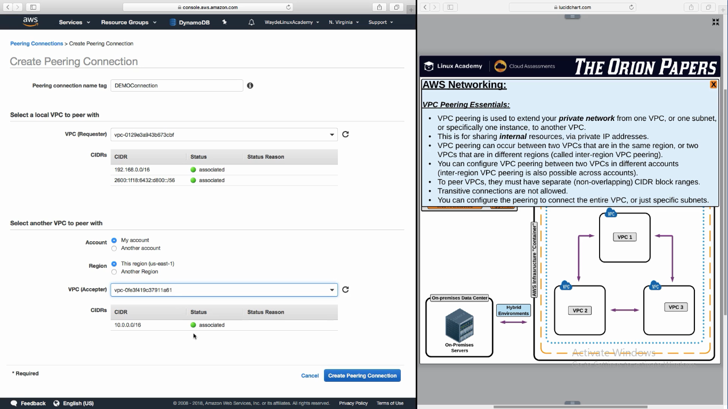

This peering connection will have an id and that will be the target in route tables

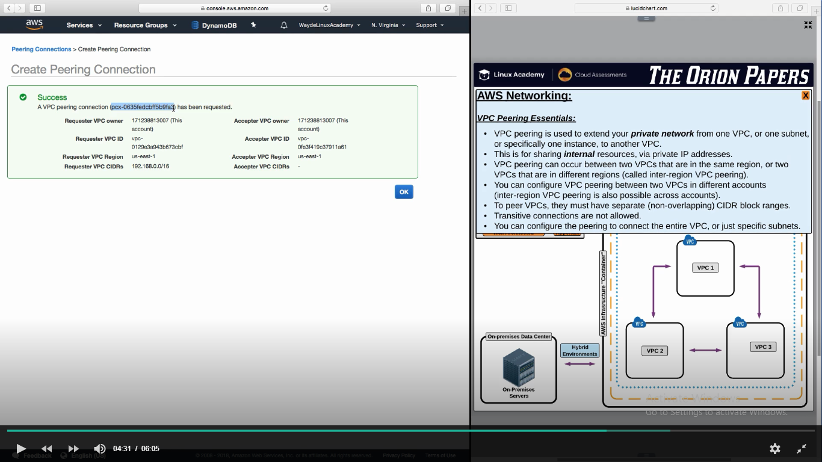

Account owner have to accept the connection request

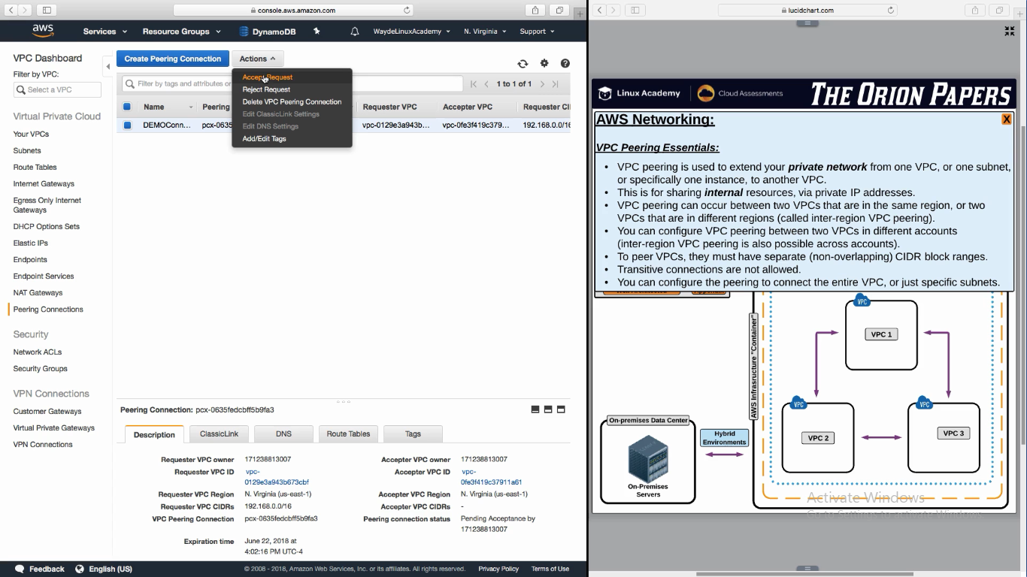

Go to the route table of each VPC and update the “Target ID” which we obtained while creating VPC peering connection

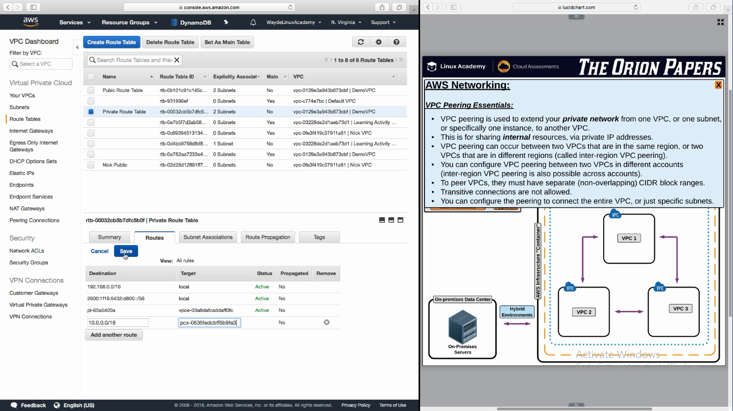

Do the same in the other VPC route table